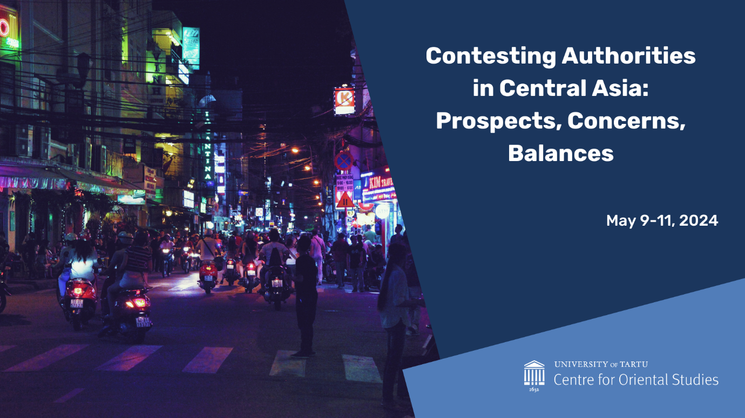

Welcome to our Workshop!
https://kultuuriteadused.ut.ee/en/content/international-workshop-contesting-authorities-central-asia-prospects-concerns-and-balances
It is possible to follow the event online - sessions 1-4 of the Workshop and the Webinar “University of Tokyo - University of Tartu, Chinese, Russian and Central Asian” (Estonia time). Please, register by May 7: https://forms.gle/Pn16or1UCwTnEd1ZA

DAY 1 MAY 9
Delta Centre, room 2035 (Narva mnt 18)

Registration and opening: 8:30-9:00
Introduction: Alevtina Solovyeva (Centre for Oriental Studies, University of Tartu) and Vladimir Sazonov (Centre for Oriental Studies, University of Tartu; Estonian Military Academy)

Panel 1 Borders: 9.00-11.00
Moderator: Vladimir Sazonov
Ivan Peshkov (Adam Mickiewicz University in Poznan), Borderland and Border Studies in Central Asia
Vladimirs Zaguzovs (Consortium of EU Member States and ICMPD), EU contribution to border security and trade facilitation. Challenges and lessons learnt
Carl Frederick Liles (University of Tartu), Transborder Regional Identities in Peace and Conflict: The Case of the 2021-22 Kyrgyzstan-Tajikistan Border Clashes
Andres Herkel (University of Tartu; Postimees), Dreaming about peace and cooperation between independent states in the Caucasus

Pause: 11.00-11.15

Panel 2 Threats, policies and structures: 11.15-13.15
Moderator: Alevtina Solovyeva

Vladimir Sazonov (University of Tartu; Estonian Military Academy), ISIS-Khorasan: ideology, propaganda, terrorism and influence activity in Central Asia and Afghanistan

Julien Theron (Sciences Po Paris School of International Affairs; European Commission Joint Research Centre), Analysing Hybrid Threats Through the CORE Model: Decrypting Autocratic Strategies in the Grey Zone [online]
Maryia Danilovich (University of Göttingen; Uppsala University), Fresh-Form Multilateralism & Structured Power Projection: China’s Recent Engagement in Central Asia
Aigerim Nurseitova (University of Tartu), The Ripple Effect of the Central Asian Multi-Vector Diplomacy

Lunch: 13.15-14.15

Panel 3 Shifts in Foreign presence and internal processes: 14.15 - 16.45
Moderator: Mari Valdur
Helen Haas (University of Tartu), (Re)making the Turkic World: Power of Shared Values
Märt Läänemets (Estonian Academy of Security Sciences), China's interests and activities in the Post US Withdrawal Afghanistan. A geopolitical shift in the region?
Shugyla Kilybayeva (Tallinn University of Technology), The Shift in Kazakhstan Citizens’ Political Participation: Pre and Post the 2019 Political Transition
Aimar Ventsel (University of Tartu), The unsolved language issue in Kazakhstan: the role of a president in decision-making and popular mood
Polina Vlasenko (Tallinn University), Emerging surrogacy mobilities and markets across Central Asia and the Caucasus
Pause: 16.45-17.00
Key-note lecture: 17.00-18.00 (online)
Erica Marat (College of International Security Affairs, National Defense University, USA), Decolonial Disruptions in Central Asia

Reception: 19:00-22:00

DAY 2 MAY 10
Delta Centre 2035, (Narva mnt 18)

Webinar University of Tokyo - University of Tartu, Chinese, Russian and Central Asian Policies: 9.00-11.00
Moderator: Alevtina Solovyeva (Centre for Oriental Studies, University of Tartu)

Introduction: Elo Süld (Tartu University Asia Centre)

Shin Kawashima (University of Tokyo), China’s Central Asian Policy: Great Western Development, Neighborhood Diplomacy, and One Belt, One Road
Discussant: Maryia Danilovich (University of Göttingen; Uppsala University)

Mihoko Kato (University of Tokyo), Russia’s Turn to the East Policy after the War in Ukraine
Discussant: Vladimir Sazonov (Centre for Oriental Studies, University of Tartu; Estonian Military Academy)

Ryota Saito (University of Tokyo), Dynamics and Diversification of Development of logistics in Central Asia
Discussant: Ivan Peshkov (Adam Mickiewicz University in Poznan)

Pause: 11.00-11.15
Panel 4 Anthropology of regional cases, Central Asia and neighbourhood: 11.15-13.15
Moderator: Aimar Ventsel
Elira Turdubaeva (Ala-Too International University) Regional Media in Kyrgyzstan: Caught Between State Propaganda and Local Voices
Joseph Bristley (University of Cambridge), Vanished Others: Russian soldiers, Chinese farmers, and the geopolitics of the Selenge basin
Sayana Namsaraeva (University of Cambridge), ‘Poisoned Waters and Tamed Birds’: historical and present-day dehumanizing and ‘super-humanising’ Sinophobic narratives from the Russian Siberia
Mari Valdur (University of Tartu), Mothers United: Education, Childcare, and Casual Feminism in Ulaanbaatar

Lunch: 13.15-14.15

The closed work session of presenters and organisers: 14.15-17.00
Moderators: Vladimir Sazonov, Alevtina Solovyeva, Betti Marie Peterson, Mari Valdur

Introduction: Alevtina Solovyeva (University of Tartu), Central Asia: internal /external conceptualisations and integrational structures - 14.15-14.30

Roundtable and strategic discussions, “Central Asia - Threats, Projects, Prognosis”: 14.30-17.00

DAY 3 MAY 11
Centre for Oriental Studies, Ülikooli 18, room 226

Conclusive discussions and planning: 10:00-11:00

Cultural program: 11:00-13:00

