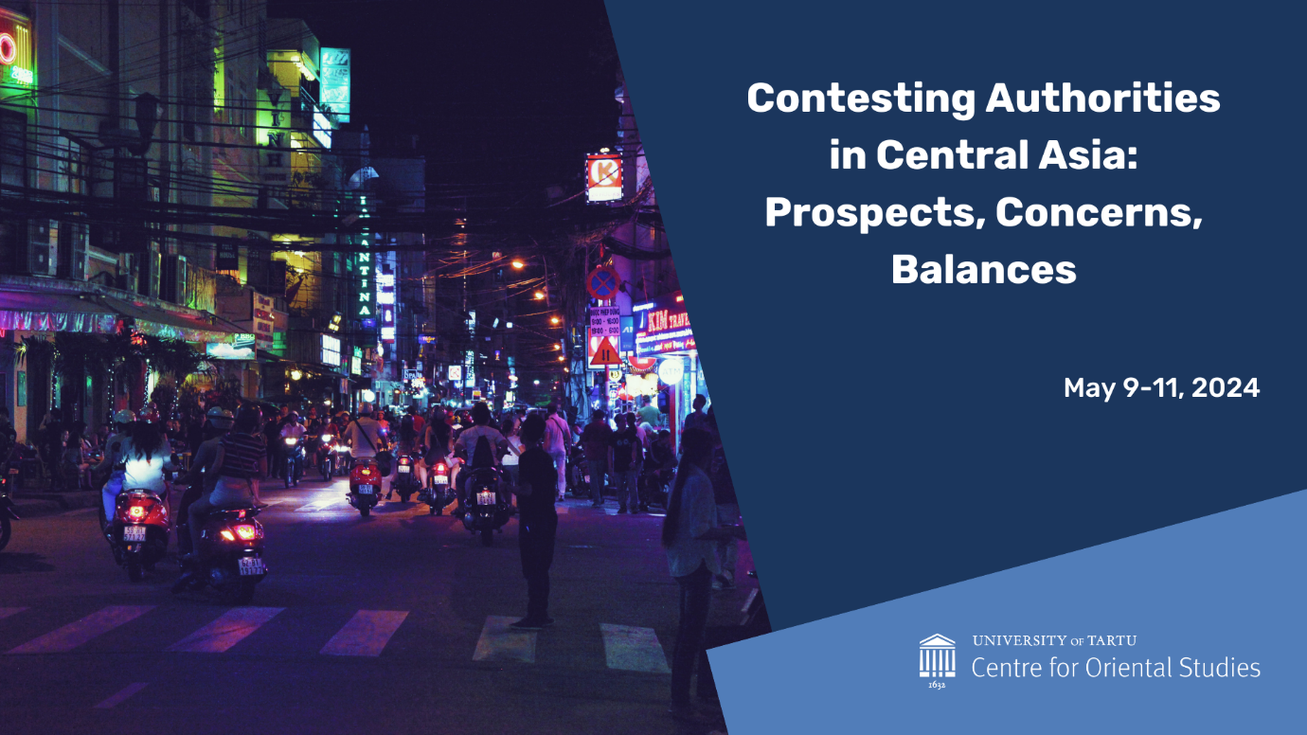

UNIVERSITY OF TOKYO - UNIVERSITY OF TARTU WEBINAR:
CHINESE, RUSSIAN AND CENTRAL ASIAN

May 9, 9.00-11.00
Moderator: Alevtina Solovyeva (Centre for Oriental Studies, University of Tartu)

Introduction: Elo Süld (Tartu University Asia Centre)

Shin Kawashima (University of Tokyo), China’s Central Asian Policy: Great Western Development, Neighborhood Diplomacy, and One Belt, One Road
Discussant: Maryia Danilovich (University of Gütingen; Uppsala University)

Mihoko Kato (University of Tokyo), Russia’s Turn to the East Policy after the War in Ukraine
Discussant: Vladimir Sazonov (Centre for Oriental Studies, University of Tartu; Estonian Military Academy)

Ryota Saito (University of Tokyo), Dynamics and Diversification of Development of logistics in Central Asia
Discussant: Ivan Peshkov (Adam Mickiewicz University in Poznan)

SPEAKERS:
Shin Kawashima is a Professor at the Department of International Relations at the Graduate School of Arts & Sciences, the University of Tokyo. He is also the Executive Director of Research of the Nakasone Peace Institute, an adviser to the National Security Agency (2014-2018), a Senior Fellow of the National Security Agency (2018-), an associate member of the Science Council of Japan (2014-) and others. He was engaged in education and research in Taiwan, China and the United States. His research covers Chinese/Taiwanese diplomatic history and contemporary international relations in East Asia. Some of Kawashima's articles on contemporary China can be found on the following web page.
https://www.thinkchina.sg/shinkawashima
https://thediplomat.com/search?gcse=shin+kawashima

Mihoko Kato is a Lecturer at Hiroshima Peace Institute, Hiroshima City University. She holds a PhD in History and Area Studies from Hokkaido University. Her current research interest is Russia’s foreign policy toward East Asian countries, in particular former Soviet partners such as China, North Korea, and Vietnam from the end of the Cold War to the present. Her publications include “Competing Sovereignty Regimes within Northeast Asia” In Geo-Politics in Northeast Asia, edited by Akihiro Iwashita, Yong-Chool Ha, and Edward Boyle, (London: Routledge, 2022), pp. 157-170; Russia in the Asia-Pacific Region: Seeking a New International Order after the End of the Cold War and Multilateralism (Hokkaido UP, 2014) [in Japanese].

Ryota Saito is an Assistant Researcher at the Institute for Russian & NIS Economic Studies, Japan Association for Trade with Russia & NIS (ROTOBO). The areas of the researcher’s expertise include international relationships, development issues, water security issues and water management issues in Central Asia.
Previously, Ryota has held various positions, including visiting fellow at the Academy of Science of the Republic of Uzbekistan, Intern at the Scientific Information Center of the Interstate Commission for Water Coordination of Central Asia (SIC-ICWC), Attache at the Embassy of Japan to Kyrgyz republic, Research Fellow at the Sasakawa Peace Foundation (Japan). His publications in Japanese include (in English translation titles): “Central Asian Countries’ Diplomacies towards Afghanistan: After Independence and Presence,” 2022; “Water Consumers Associations in Uzbekistan: Current State, Issues and Perspectives,” 2015; “Empirical Study of Central Asian interstate disputes over the water resource issue: an analysis of ICWC bulletins”, 2014; and several analytical reports from think tanks, mass media and academic institution. His publication in English: “Sustainable Water Management in Central Asia and the Role of Foreign Donors – Case Study of “Water Management Improvement Project,”” 2015. He contributed chapters “Uzbekistan” and “Republic of Kyrgyz” for the book "Japanese International Cooperation in Asia: from Economic Development to Sustainable Development” 2019 [in Japanese].
https://tsukuba.academia.edu/RyotaSaito
https://www.rotobo.or.jp/

ABSTRACTS:

Shin Kawashima, China's Central Asian Policy: Great Western Development, Neighborhood Diplomacy, and One Belt, One Road
This presentation will review China's Central Asian diplomacy over the last 30 years and discuss the current Xi Jinping administration's diplomacy toward Central Asia. In this discussion, attention will be paid to the relationship between the Shanghai Cooperation Organization and other multilateral frameworks, as well as bilateral relations. In addition, China's relationship with Russia is extremely important when looking at China's policy toward Central Asia. For this reason, China-Russia relations will also be the subject of this presentation. Since the outbreak of the war in Ukraine, has the balance between China and Russia in Central Asia and the relationship of Central Asian countries with China and Russia really changed? In the past, Central Asia was said to be dominated by Russia for its military security and China for its economy. In recent years, it has also been said that China is increasing its military presence in Central Asia. In reality, however, China respects Russia's position in some respects. And it is gradually strengthening its relations with each of the Central Asian countries while building relationships with them individually.

Mihoko Kato, Russia’s Turn to the East Policy after the War in Ukraine

While some countries, such as Japan and South Korea, have imposed economic sanctions on Russia and strengthened their alliance with the US since February 2022, many countries in East Asia have avoided directly condemning the Kremlin and maintained political dialogue and economic cooperation with Russia. The latter countries have facilitated Russia’s eastward shift. The purpose of this presentation is to shed light on the basic structure of Russia's "Turn to the East Policy" after the war in Ukraine, the changes in its national priorities, and the background to these changes.
The first part discusses the growing tensions between Sino-Russian alignment and the U.S.-led alliance in East Asia. Here, I also briefly mention changes in Japan's policy toward Russia. The second part explains the background of the growing importance of ASEAN in Russia's foreign policy and its implications for Central Asia.

Ryota Saito (University of Tokyo), Dynamics and Diversification of Development of logistics in Central Asia

This presentation aims to consider the impact of the Russian invasion to Ukraine in the Central Asian (CA) countries’ diplomacy or attitude toward Russia through the case study focuses on logistics. After the crisis on 24th February 2022, the “de-Russianization” policy of CA states in the internal and external domains has been gathering attention from the international community. For example, at the Economic Forum in Saint Petersburg in 2022 the leader of Kazakhstan Kassym-Jomart Tokayev commented that his country will not recognize the two “people’s republics” in the eastern Ukraine. This event surprised the international audience because Kazakhstan has been seen as one of Russia’s partners, which has tight relations with each other. But for regional countries economic and military independence of Russian federation still has been the crucial element of the political and economic domain. Regarding this reality objective viewpoint is necessary to understand regional dynamics.
By overviewing the paths of logistical development projects in CA, this presentation discusses whether the narrative of “de-Russianization in CA” is adequate or over-expression. Maintaining logistics and supply chains is now becoming a timely question for each country. In such circumstances, the CA region seems to have the possibility or potential for discovering or developing new transportation routes such as the “middle corridor”. But this study dis-contextualize this tendency of logistical development in CA region from “de-Russianization” narratives. Regional actors continuously sought the possibility to diversify their foreign connections under the partnership donor communities after the independence as the result of the collapse of the USSR. So that it might be more adequate to argue that as a result of the “new geopolitical reality”, above mentioned tendency for diversification of logistics was escalated, but not launched as new dynamics.
This analysis provides implications for other domains in the CA region, such as linguistic situation et al. This finding may provide an objective approach to observe regional dynamics or tendencies in CA.

